Dear Parents and Carers,

A reminder that we have 2 inset days on returning to school in September on the 1st and 2nd to train all the staff with the new arrangements and procedures. Friday this week will be a 12pm finish as per the end of term.

As you know the Government have now published their guidance for the full re-opening of schools and I published this on the website earlier last week. I have provided the risk assessment plans on our website but I thought you would appreciate some basic information that has now been agreed regarding the start dates and morning arrangements. The Senior Leadership Team and I have been working hard in scrutinising the guidance this week and making the best plans to secure a successful re-integration to school for all.

As you know we have been teaching an ever increasing number of students very successfully over the last 4 weeks and they are now familiar with our NEW NORMAL. And we have continued to contact all families who have not as yet accessed learning on site to ensure they are confident for September and the start of the new term.

There are 2 things that all parents need to be aware of: firstly that we will be phasing the boys back in and secondly that the morning procedure will be slightly different. This is outlined below.
We will be putting together all the information that you will need to feel confident about your son returning to school over this week but for now please note the following:

Staggered start
It is important that we ensure everyone is confident with the school systems and feels safe; taking our time with opening up the school will ensure adequate time is given to ensure systems work well and behaviours are embedded in a safe environment.
We are, therefore, proposing to have a staggered start to the year as follows:
Day 1 Thurs 3rd September Year 7 (Class 1) only
Day 2 Fri 4th September Class 1 and Class 6
Day 3 Mon 7th September Class 1, 2 and 6
Day 4 Tuesday 8th September Class 1, 2, 5 and 6
Day 5 Wednesday 9th September Class 1, 2, 3, 5 and 6
Day 6 All classes

Changes to the morning procedure
Pupils will be driven into the car park and taxis will wait until the next pupil can enter the building, pupils will have to remain in the cab until notified by staff, pupils will be wanded, phones handed in, sanitiser used and directed to their form room, breakfast club will be in their form room the canteen is not open in the morning for pupils. (taxis that arrive past 8.45am will stop at the front and pupils will be brought through the new corridor to follow the same procedure)
Class 1 form Art upstairs
Class 2 Maths downstairs
Class 3 English
Class 4 Science (was Ste Rose room)
Class 5 Maths upstairs
Class 6 Humanities upstairs

As I’m sure you can appreciate pupils have had to get used to a number of changes over the lockdown period and coming back in September will require more of a zonal model with limited movement around the school, following on from the building work Classes 5 and 6 now have a designated toilet upstairs. Pupils will now have staggered lunches to limit the mixing of bubbles, there will be increased handwashing expectations and especially the increased cleaning of equipment, as such we ask that the boys continue to use only the pencil cases provided for them, keep the areas they use tidy, adhere to the increases in hand washing and use of sanitiser and adhere to the school behaviour policy.

Updates on the building work and the look of school
As per my previous correspondence we have changed the look of the front of school and I wanted to share with you some of the photos of the front of school so the boys can have a look before coming back in September.
Front entrance Parent/visitor area Office 1 Office 2 Staff office New corridor
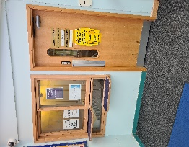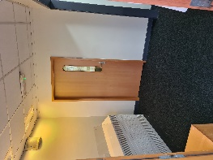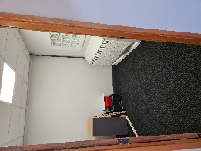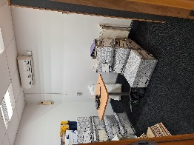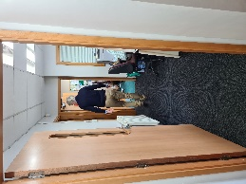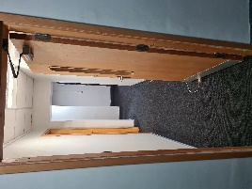

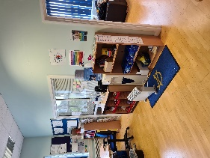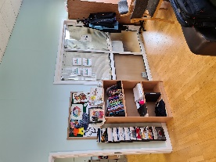
Over the summer holiday to support the use of zonal planning after 2 years of sharing an office in a classroom, we are turning our office at the back of school into a classroom, Miss K Walsh will be having the new classroom as an Art base and form room for Class 1. The pictures above are where the wall will come down and we will be moving downstairs, as the building work takes shape I will keep you updated.

From all of the staff in school we want to wish you all a safe summer holiday, it is so sad that we have not been able to celebrate with the year 11’s leaving us this year or be able to welcome the new year 7 pupils to school other than online but we wish the year 11’s all the best for the future and do keep in touch with us and we look forward to seeing all our pupils back in September.
Kind regards,

Jane Pepa

Headteacher
Clifford Holroyde Specialist SEN College
Thingwall Lane
Liverpool
L14 7NX

0151 228 9500

