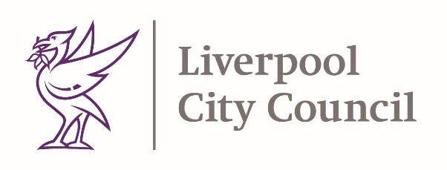

16th April 2021

Dear Parent / Carer,
Re: COVID-19 and overseas travel
Thank you for your continued support in the fight against Coronavirus. We wanted to take this opportunity to remind you there are restrictions in place for international travel.
You can only travel internationally from England where you have a reasonable excuse to leave the UK, such as work. International holidays are not permitted.

Red list travel ban countries
If you have been in or through any of the countries listed here:
Coronavirus (COVID-19): red list travel ban countries - GOV.UK (www.gov.uk)
in the previous 10 days, you will be refused entry to the UK.
If you are a British or Irish National, or you have residence rights in the UK, you will be able to enter. You must quarantine in a government approved hotel for 10 days.

Currently, everyone allowed to enter England from outside the Common Travel Area (Ireland, the Channel Islands or the Isle of Man) must:

- quarantine for 10 days
- take a coronavirus test on day 2 and day 8 of quarantining unless your job permits exemption. You will have to pay for a private test: shorturl.at/gmxZ4
- follow the national social distancing rules

If you are self isolating and require further help with shopping, getting prescriptions or mental health please visit here: shorturl.at/fjyK0 Alternatively, please call freephone 0800 169 3032. Our lines are open 8am to 6pm Monday to Friday.
This guidance is available in a range of alternate languages: shorturl.at/zHJK6
Face coverings
When picking up or dropping off children from school or nursery you should wear a face covering, unless you are exempt and always avoid close contact with others.
Stay safe and many thanks for your continued support.
Matt Ashton
Director of Public Health, Liverpool
Steve Reddy
Director of Children’s Services, Liverpool

General Covid-19 advice
If you have any of the main symptoms of coronavirus (COVID-19), get a PCR test as soon as possible. Stay at home until you get the result.
The main symptoms of coronavirus are:
- a high temperature – this means you feel hot to touch on your chest or back (you do not need to measure your temperature)
- a new, continuous cough – this means coughing a lot for more than an hour, or 3 or more coughing episodes in 24 hours (if you usually have a cough, it may be worse than usual)
- a loss or change to your sense of smell or taste – this means you've noticed you cannot smell or taste anything, or things smell or taste different to normal
People who are sick with coronavirus may have other flu like symptoms such as:
- body aches
- persistent headaches
- sore throat
- tiredness
- shortness of breath
- nausea or
- diarrhoea
If you don’t have any of the main symptoms of coronavirus, you don’t need to isolate until you get your result, however you do need to continue to take the usual measures to protect yourself and others from illness.
General Testing (not part of returning to England)
People with symptoms can get a test here:
https://liverpool.gov.uk/communities-and-safety/emergency-planning/coronavirus/how-to-get-tested/tests-for-people-with-symptoms/
People without symptoms can access our community testing sites here: https://liverpool.gov.uk/smarttesting
Testing after travel from overseas: www.gov.uk/guidance/coronavirus-covid-19-testing-for-people-travelling-to-england?step-by-step-nav=8c0c7b83-5e0b-4bed-9121-1c394e2f96f3
Mental wellbeing
Don’t forget about your own self-care. Discover our supportive online mental wellbeing space for adults: qwell.io

