

12th May 2021

Dear Head Teacher,

EU Settlement Scheme

The UK has now left the European Union and you’ll be aware that citizens of the EU, Norway, Iceland, Liechtenstein, and Switzerland who wish to continue living and working in the UK must apply to the EU Settlement Scheme (EUSS) for settled or pre-settled status. The deadline to do this is 30 June 2021.

Applying to the scheme is very important as it means that people will protect the rights that they currently have, including the right to employment, to rent a home, and to access healthcare and benefits.

Citizens of these countries who are also parents must ensure that they also apply on behalf of their children, whether their children are citizens of the countries covered by the scheme or, if they are not citizens of those countries, their parent(s) is/are.

It is now fewer than 50 days until the EUSS closes to applications. We would be grateful if you could remind parents of your pupils of the need to apply to the scheme as soon as possible and certainly ahead of the deadline.

Applications should be made online via GOV.UK and are free.

If people need advice prior to making their application they should contact Citizens’ Advice in Liverpool as this is the commissioned service to provide support. They can call 0151 522 1725 or email euss@caliverpool.org.uk

Best wishes,
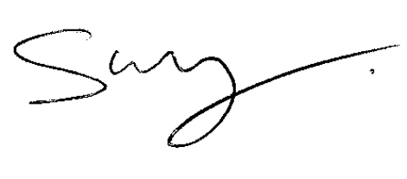
Steve Reddy, Jonathan Jones,
Director, Director of Education,
Children and Young People’s Services, Liverpool City Council.
Liverpool City Council.

