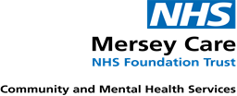
Immunisation Team
Lifehouse
Summers Road
Brunswick Business Park
Liverpool
L3 4BL
Telephone: 0151 295 3833

Date: 01/07/2020

Re: School Based Immunisations

Dear parent/carer,
We hope this letter finds you and your family well.
School closures during the COVID pandemic forced school based immunisations sessions to be suspended however we are working with our immunisation service to ensure our school population can still be protected against important vaccine preventable diseases.
We are therefore asking parents/carers to contact the immunisation team to make an appointment on 0151 295 3833, appointments will be limited due to social distancing measures and to ensure your childs safety all current government guidance and infection control measures will be in place.
Further information regarding vaccinations can be found at: https://www.gov.uk/government/publications/immunisations-for-young-people
Please note that if you have booked a space for immunisations on the 10th July then school will be notified and transport will be arranged on this occasion.

Yours sincerely
School aged immunisation team

