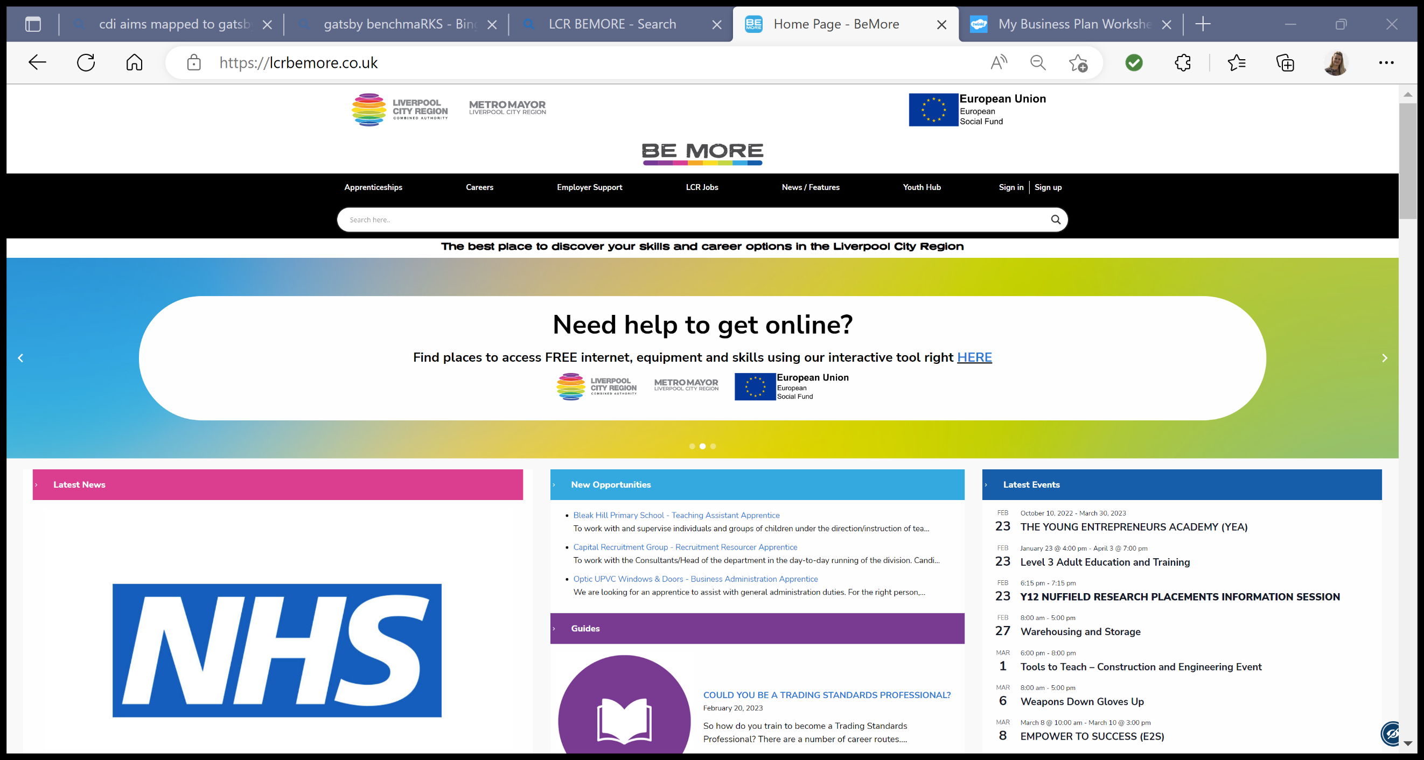

**LCR Careers Hub**

**LMI Enterprise Challenge**

***In Partership with LCR Be More and Liverpool One***

**Name:**

**School/College:**

**Year Group:**

**Teacher:**

**Task**

We would like you to design a business or product that will benefit the Liverpool City Region (LCR). Your idea needs to relate to one of the LCR growth sectors. If you choose a product, this can be an enhanced version of something that already exists. If you can design a new product then you never know where this could take you….!

*Any school/college entries must be submitted to your Careers Leader/teacher.*

**Tips and Ideas**

* Think about if you will be offering products or services? A **product** is a physical object that a person may purchase or rent. A **service** is something that you can provide to meet a demand. Such as, web design.
* Think about how this business idea could benefit the LCR – is there a gap in the market, will it bring in money, jobs etc.

**Researh Criteria:**

* Use the LCR Be More site to research the Growth Sectors and explore local Labout Market Information (LMI): [LCR Be More](https://lcrbemore.co.uk/careers/growth-sectors/)

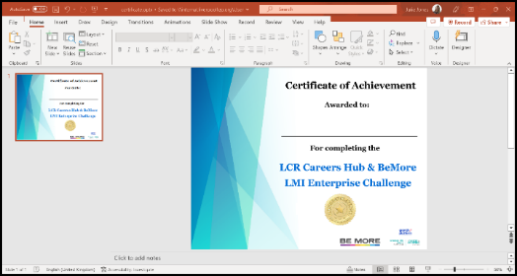***Upon completion please submit this document to your teacher to judge.***

**All entries will receive an exclusive Enterprise certificate.**

**All school/college winners will be then be put forward to be judged by the LCR Careers Hub and the LCR Be More teams. The overall winner will receive a £50 Liverpool ONE Voucher and there will be some runner up prizes!**

The Liverpool City Region is made up of over **44,000** businesses which are grouped into Growth Sectors. Ranging from sole traders through to multinational organisations, these businesses have contributed over **£32 billion** to the local economy since 2014.

**Businesses are grouped into the following Growth Sectors:**

1. Advanced Manufacturing
2. Construction & Built Environment
3. Digital & Creative
4. Green Growth
5. Health & Life Sciences
6. Maritime & Logistics
7. Professional & Business Services
8. Visitor Economy
9. Innovation

**Task: Connect the sector name to the corresponding image by drawing a line.**

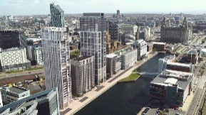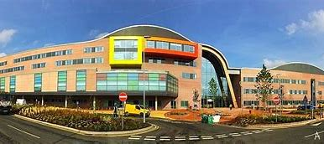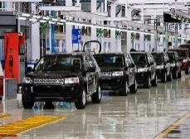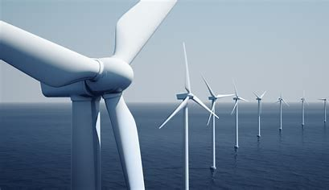

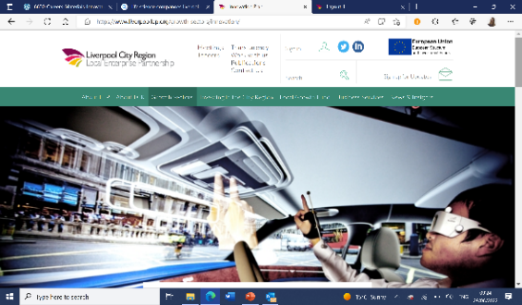

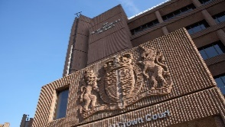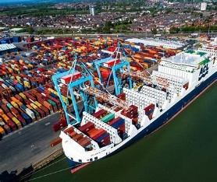

**What is a Growth Sector?**

* **A sector** is another name for aprofessional category that describes the types of businesses that exist within it. An example would be car manufacturing which is part of the Advanced Manufacturing.
* **A growth sector** is a part of an economy which experiences a higher-than-average growth rate as compared to other sectors. Their growth is a result of demand for new products or services offered by companies in the field.

An example would be the Digital & Creative sector in 2018, there were 4,425 digital & creative workplaces in Liverpool City Region; since 2010, the City Region has become home to an additional 1,245 Digital & Creative workplaces (39% growth).

**What is Enterprise?**

Business enterprise: Entrepreneurs set up businesses for a variety of reasons. Ultimately however, successful businesses survive by meeting customer needs. Entrepreneurs must have a range of characteristics and motives to create a successful business.

**Abbreviations:**

* **LMI:** Labour Market Information is information about current jobs and employment. LMI gives facts and figures.
* **LCR:** Liverpool City Regio

|  |
| --- |
| **Business Name** |
| **Name and Strapline: A strapline is a short, easily remembered phrase used by an organisation so that people will recognise it or its products. Eg Nike: Just do it.** |
| **My chosen sector and why have you chosen this sector?** |
| **Business Idea** |
| **What is your Business Idea? What will you sell / produce?** |
| **What resources will you need to get started? Eg: Investment, Machinery, Buildings, Vehicles, Uniform, website etc:** |
| **Target Customer** |
| **Who are your customers? Example: The elderly, teenagers, other business owners?** |
| **How will you promote your business to them? Eg: Social Media, Newspapers, TV etc.** |
| **Marketing** |
| **Who are your business competitors? Use the Be More website or google to find other businesses in the region offering a similar product or service.** |
| **Financials** |
| **What will you charge for the product or service?** |
| **How much money do you expect to make in the first year and how?** |
| **Product Design** |
| **Product Design – If your business idea involves designing and selling a product, sketch and label your idea here.** |
| **Logo Design** |
| Logo Design. Design your company logo here. A logo might be used on a website, uniform, sign, or advertisement. |

***Congratulations on completing this Enterprise Challenge and creating your first business plan.***

**Extension Task:**

If you have enjoyed this task and would like to establish your own business in the future you might want to consider studying a business-related course in school at GCSE level, in Sixth Form, Further Education College, University or via an apprenticeship.

Start your search online [here](https://lcrbemore.co.uk/careers/) and speak to your school/college Careers Advisor about this.

You can also learn more about self-employment and get support from the Prince’s Trust.

The Prince's Trust helps young people aged 18 to 30 who want to set up their own business in England - [www.princes-trust.org.uk/help-for-young-people/support-starting-business](http://www.princes-trust.org.uk/help-for-young-people/support-starting-business)